NOT Operation





*FIGURE 1*

|  |  |
| --- | --- |
| **Truth Table** | |
| **A**  **SW1** | **B**  **L1** |
| **0** | **1** |
| **1** | **0** |

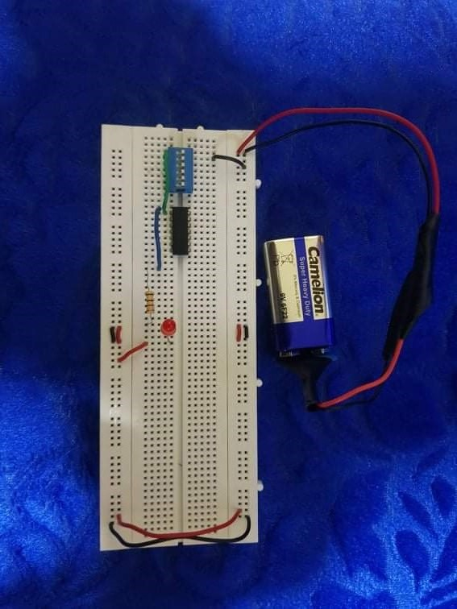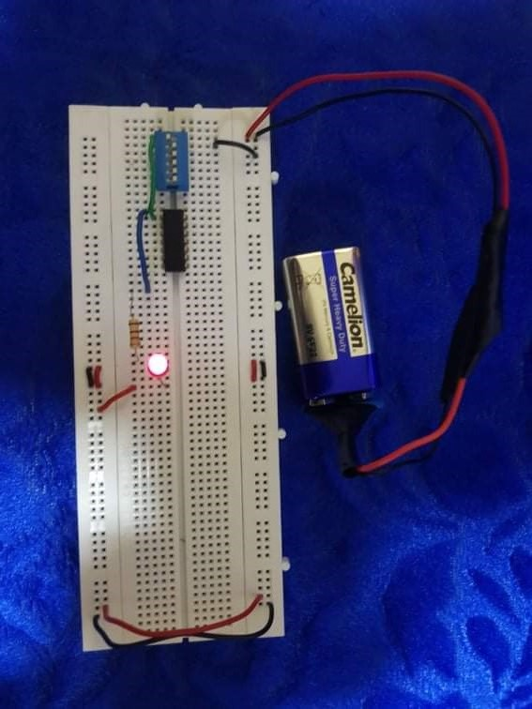

*FIGURE 3*

|  |  |
| --- | --- |
| **Truth Table** | |
| **A**  **SW1** | **B**  **L1** |
| **0** | **1** |
| **1** | **0** |

